**Project Design Phase-II**

**Data Flow Diagram & User Stories**

|  |  |
| --- | --- |
| Date | 31 January 2025 |
| Team ID | PNT2025TMID02554 |
| Project Name | Global Malnutrition Trends: A Power BI Analysis (1983-2019) |
| Maximum Marks | 4 Marks |

**Data Flow Diagrams:**

**To create a Data Flow Diagram (DFD) for your project on Global Malnutrition Trends Analysis (1983-2019) in Power BI, we need to define how data flows through your system.**



Example: DFD Level 0 (Industry Standard)

**Example: • Data Sources (Entities):**

**WHO/UNICEF, Government Portals, and NGOs provide raw data.**

**• Data Storage & Processing:**

* **Raw data is stored, cleaned, and preprocessed.**

**• Data Analysis:**

* **Processed data undergoes statistical analysis to find trends.**

**• Visualization & Reporting:**

* **Power BI is used to generate insights.**

**• Final Reports & Decision Making:**

* **Reports are generated for policymakers & analysts.**

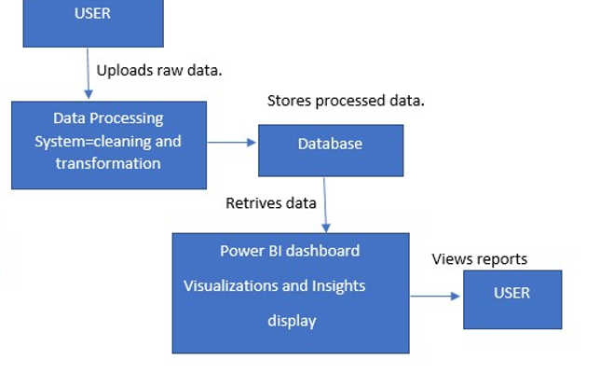

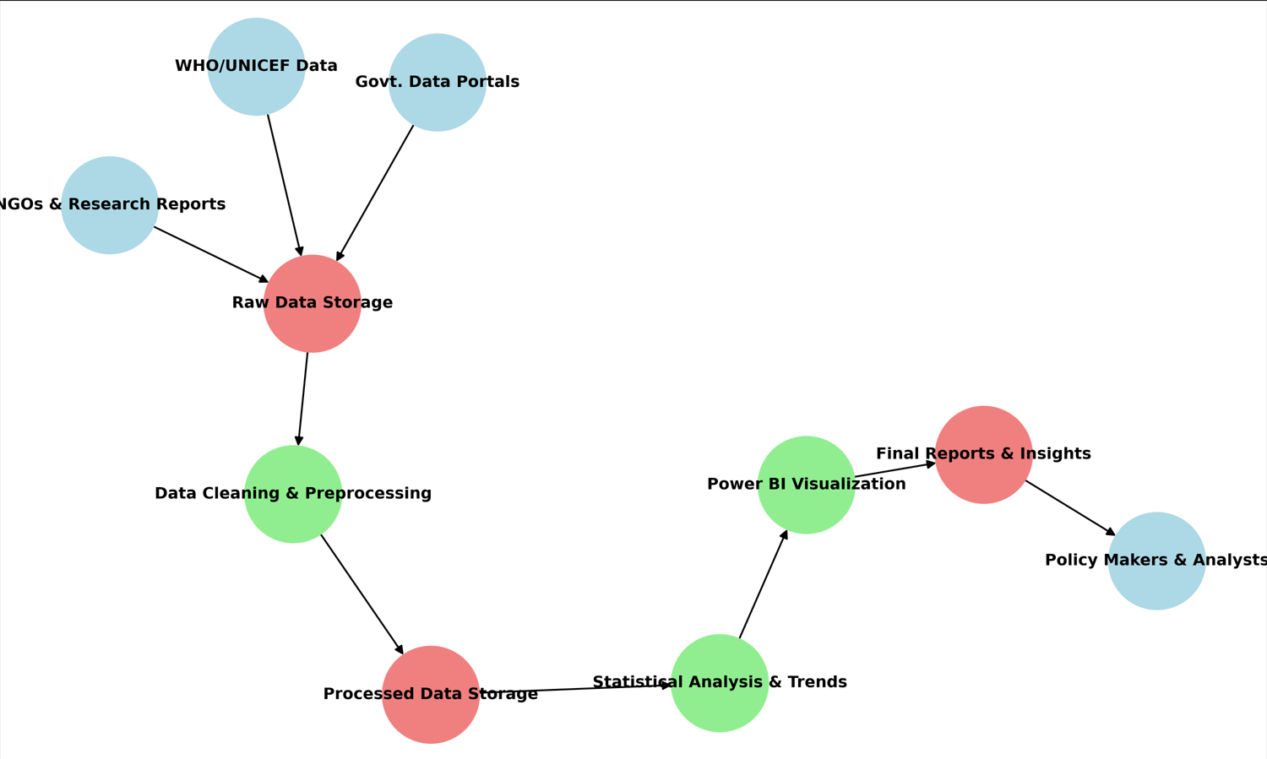

**User Stories**

Use the below template to list all the user stories for the product.

| **User Type** | **Functional Requirement (Epic)** | **User Story Number** | **User Story / Task** | **Acceptance criteria** | **Priority** | **Release** |
| --- | --- | --- | --- | --- | --- | --- |
| Data Analyst | Data Collection | USN-1 | As a data analyst, I can collect and load malnutrition datasets (1983-2019). | Data is successfully stored in the database. | High | Sprint-1 |
| Data Analyst | Data Cleaning | USN-2 | As a data analyst, I can clean and pre-process the dataset. | Data has no missing or inconsistent values. | High | Sprint-1 |
| BI Developer | Data Transformation | USN-3 | As a BI developer, I can normalize and merge datasets for analysis. | Data is formatted correctly for visualization. | Medium | Sprint-2 |
| BI Developer | Visualization | USN-4 | As a BI developer, I can create Power BI dashboards to show malnutrition trends. | Dashboard displays accurate trend analysis. | High | Sprint-3 |
| Researcher | Insights & Reporting | USN-5 | As a researcher, I can analyse malnutrition trends by region. | Report includes correlations and key findings. | Medium | Sprint-4 |
| End User | Report Access | USN-6 | As an end user, I can access the final reports on malnutrition trends. | Users can download reports in PDF format. | High | Sprint-4 |
|  |  |  |  |  |  |  |
|  |  |  |  |  |  |  |
|  |  |  |  |  |  |  |
|  |  |  |  |  |  |  |
|  |  |  |  |  |  |  |
|  |  |  |  |  |  |  |